**Computer Studies 7010/02**

**Company Name: Doric Engineering Pvt. Ltd**

**Project Name: Generator Management System**

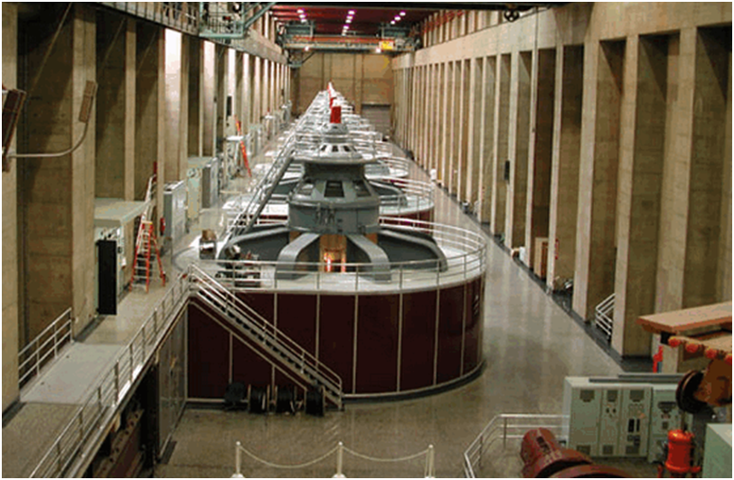

**Oxford International School**

**Candidate Name: Ismail Faruk**

**Centre Number: BD009**

**Candidate Number: 7002**

|  |  |  |
| --- | --- | --- |
| ***Phase*** | ***Contents*** | ***Page*** |
| **1** | **ANALYSIS** | **01-09** |
| **2** | **DESIGN** | **10-23** |
| **3** | **Implementation** | **24-48** |
| **4** | **Testing** | **49-69** |
| **5** | **Documentation** | **70-90** |
| **6** | **Evaluation** | **91-92** |

|  |  |  |
| --- | --- | --- |
| **Sub Contents** | | **Page** |
| **Analysis** | |  |
| **1** | **Description of the Problem** | **01-04** |
| **2** | **Objectives** | **04-05** |
| **3** | **Description of existing solution** | **05-07** |
| **4** | **Evaluation of existing solution** | **08-08** |
| **5** | **Description of other possible solutions** | **09-09** |
| **Design** | |  |
| **6** | **Action Plan** | **10-11** |
| **7** | **System Flowchart** | **11-12** |
| **8** | **Description of the method of solution** | **13-20** |
| **9** | **Hardware requirement** | **21-21** |
| **10** | **Software requirement** | **21-23** |
| **Implementation** | |  |
| **11** | **Method of solution** | **24-31** |
| **12** | **Accurate method of solution** | **32-32** |
| **13** | **Programming coding** | **33-48** |
| **Testing** | |  |
| **14** | **Test strategy** | **49-65** |
| **15** | **Test results** | **66-69** |
| **Documentation** | |  |
| **16** | **Technical Documentation** | **70-82** |
| **17** | **User Documentation** | **83-90** |
| **Evaluation** | |  |
| **18** | **Evaluation of the new system** | **91-91** |
| **19** | **Suggested Improvement** | **92-92** |